**NarcoTech**

**Design Document**

**Alexa Physio Reminder Skill**

**Appointment Reminder System for O.P.S**

**Team Members Contact**

Tarika Birch (PRO) tarika.birch@mycavehill.uwi.edu

Dwayne Archer dwayne.archer@mycavehill.uwi.edu

Kai Hill kai.hill@mycavehill.uwi.edu

Aaron Grimes aaron.grimes@mycavehill.uwi.edu

Kelilah Mayers kelilah.mayers@mycavehill.uwi.edu

Contents

Introduction 3

Project Overview 3

Data Design 4

Architectural Design 5

System Architecture 5

Technology Stack Architecture 5

Infrastructure Requirements 5

Interface Design 6

System Interface Design 6

User Interface Design 6

User Interaction - Scenario 1 6

User Interaction - Scenario 2 7

User Interaction - Scenario 3 7

Use Case 8

Sample Utterances 9

Component-Level Design 10

Module Overview 10

Control Flow Diagram 11

Detailed Design 12

# 

# Introduction

**Purpose of the Document**

The purpose of this document is to serve as a blueprint for the development of the proposed Alexa Physio Reminder skill. The design document will aim to provide a common understanding of the system’s structure and functionalities. The details outlined in this document will serve as a guide for developers during implementation, as well as a reference for future development or maintenance activities.

**Document Overview**

The design document provides a comprehensive overview of the Alexa Physio Reminder Skill for Optimal Physiotherapy Services. The document outlines the data design, architectural design, component-level design, detailed design, interface design and security and performance considerations regarding the structure of the system. This document details the intricacies of the system’s design to ensure successful implementation.

# Project Overview

**Project Description**

The scope of the project involves the development and implementation of an Alexa Skill designed to provide appointment reminders and information for physiotherapy sessions at Optimal Physiotherapy Services (O.P.S).

**Project Objectives**

The primary objective of this project is to provide Optimal Physiotherapy Services with a tool to remind their older clientele suffering with Repetitive Strain Injuries, about their upcoming appointments. This will be completed through the utilization of the Alexa Skills Kit. Through the implementation of this project, we aim to:

* **Reduce Missed Physiotherapy Sessions:** The skill should reduce missed appointments by providing a platform to facilitate reminders about these upcoming appointments.
* **Improve Patient Recovery Times:** Through reducing the number of missed appointments, patients should no longer experience prolonged post-rehabilitative care.

**Reference Documents**

For a better understanding of the specifications associated with this product, a review of the following document should be carried out:

* Specifications & Requirements Documentation

# Data Design

The data will be stored using a table in DynamoDB on Amazon Web Services. The table will be populated as follows:

|  |  |  |  |  |
| --- | --- | --- | --- | --- |
| **id** | **dateOfApp** | **timeOfApp** | **therapistOfApp** | **patientId** |
| d2023-07-11t12:00pamzn1.ask.account.EJRFEWJRGWEJRGWEJAJSBASDJBADJFBAJDFBWEFJBWERF | 2023-07-11 | 12:00 | Zoe | amzn1.ask.account.EJRFEWJRGWEJRGWEJAJSBASDJBADJFBAJDFBWEFJBWERF |
| d2024-11-12t9:00pamzn1.ask.account.RIBWRIBRWIVBWRHIBRTHBRTIBERIBERBREIBRTEBFQWHE | 2024-11-12 | 9:00 | Rennae | amzn1.ask.account.RIBWRIBRWIVBWRHIBRTHBRTIBERIBERBREIBRTEBFQWHE |
| d2023-05-04t16:00pamzn1.ask.account.WNDQNDWKENFKEFNKQWNEFWKENFKWEFNWKERFERR | 2023-05-04 | 16:00 | Iman | amzn1.ask.account.WNDQNDWKENFKEFNKQWNEFWKENFKWEFNWKERFERR |
| d2024-03-05t14:00pamzn1.ask.account.ZHVEWJHVINVJCBIWJEBFBVIWEVIWEBVWIEBVWERVWER | 2024-03-05 | 14:00 | Adrian | amzn1.ask.account.ZHVEWJHVINVJCBIWJEBFBVIWEVIWEBVWIEBVWERVWER |

## Dictionary

|  |  |  |
| --- | --- | --- |
| Variable Name | Type | Purpose |
| id | string | Identification for an appointment |
| dateOfApp | string | Date of an appointment |
| timeOfApp | string | Time of an appointment |
| therapistOfApp | string | Name of the therapist associated with the appointment |
| patientId | string | Identification for the patient associated with the appointment |

# Architectural Design

System Architecture

**Frontend:** Interaction with this skill will be facilitated through voice commands and responses with Alexa.

**Backend:** Processing user requests, managing the appointments and sending reminders will be facilitated through AWS Lambda.

**Database:** Storage of user identification and appointment records will be facilitated through DynamoDB.

Technology Stack Architecture

**Alexa Skills Kit:** The development platform for building Alexa skills, allowing developers to create voice-driven experiences.

**Amazon Web Services (AWS):** Cloud services that host the skill's backend logic and data storage.

**AWS Lambda:** Powers the backend logic and executes functions triggered by user commands.

**DynamoDB:** Database used to store and retrieve data.

Infrastructure Requirements

1. **Hardware:** The skill will require an Alexa-enabled device with a working microphone and speaker. Some examples of these devices include:
   1. Alexa Echo Devices
   2. Smart Home Devices
   3. Phone/Tablet
   4. Computer
2. **Software:** The skill is compatible with devices running the latest version of the Alexa app.
   1. Users should ensure their Alexa-enabled device has the latest software updates installed for optimal performance.
   2. The skill may have additional compatibility with certain operating systems on smartphones, tablets, or computers when accessing Alexa through the Alexa app.
3. **Internet Connectivity:** Users will need a stable internet connection in order for the skill to function properly.
   1. For a smooth experience, a minimum of 50 Mbps or more may be preferable.
   2. Poor internet connectivity may affect the skill’s functionality.

# Interface Design

## System Interface Design

**Frontend – Alexa**

The user will initiate interaction through uttering a voice command to the Alexa-enabled device. Alexa will then process the voice command received and forward the request to the backend AWS Lambda function. Once processing is completed by the Lambda function, a response will be generated and communicated back to the user through the Alexa interface which either confirms the addition, deletion or update of a reminder or returns the requested appointment information.

**Backend – AWS Lambda**

AWS Lambda is the serverless computer service which will receive the request from Alexa and process the user’s intent. This function will extract the relevant information and use these details to complete the relevant process. The Lambda function will interact with DynamoDB to store or retrieve relevant information such as appointment dates and times or associated the therapist. The interface between Alexa and AWS Lambda will serve as the connection between the frontend and the backend of the skill.

**Data Storage – DynamoDB**

The Lambda function will interact with the AWS database service, DynamoDB to store and retrieve appointment information. DynamoDB will manage the user identification, appointment details and therapist information.

## User Interface Design

### User Interaction - Scenario 1

**User Profile:** Sarah is an older patient at Optimal Physiotherapy Services (O.P.S.) who wants to set a reminder for her upcoming physiotherapy appointment so that she doesn’t forget it.

**Context:** Three (3) days before Sarah’s scheduled physiotherapy appointment, she decides to set the reminder using the Amazon Echo Device in her home which has the Alexa reminder skill enabled.

**User Actions:**

1. Sarah receives a call from O.P.S. on Monday morning, informing her that her physiotherapy appointment is scheduled for Thursday at 2pm.
2. She walks into her room, where her Echo device is located.
3. She invokes the reminder assistant skill.
4. She uses the command “Alexa, remind me about my physiotherapy appointment on Thursday at 2:00 PM.

**System Response:** The Alexa reminder skill acknowledges Sarah's request with a confirmation message: "Sure, I'll remind you about your physiotherapy appointment on Thursday at 2:00 PM."

**Outcome:** Sarah has successfully set a reminder for her upcoming physiotherapy appointment, giving her peace of mind that she won't forget the appointment. The system will send her a reminder at the specified time to ensure she is prepared for her appointment.

### User Interaction - Scenario 2

**User Profile:** Gerald is a 73-year-old Patient at Optimal Physiotherapy Services (O.P.S) who would like to delete a previously set reminder for his physiotherapy appointment to avoid receiving unnecessary notifications.

**Context**: Two (2) days before Gerald's scheduled physiotherapy appointment, he receives a call from O.P.S. saying his usual physiotherapist will be out of the island on holiday this week. Gerald decides to use his Kindle which has the Alexa reminder skill enabled to delete the reminder for his appointment.

**User Actions:**

1. Gerald decides he no longer needs the reminder for his physiotherapy appointment.
2. He walks to his nightstand where his Kindle is charging.
3. He invokes the reminder assistant skill.
4. Gerald says, "Alexa, delete the reminder for my physiotherapy appointment on Friday at 10:00 AM."

**System Response:** The Alexa reminder skill acknowledges Gerald's request with a confirmation message: "Sure, I'll delete the reminder for your physiotherapy appointment on Friday at 10:00 AM."

**Outcome:** Gerald has successfully deleted the reminder for his physiotherapy appointment, ensuring he won't receive notifications for it.

### User Interaction - Scenario 3

**User Profile:** Dory is an Elderly patient at Optimal Physiotherapy Services (O.P.S) who would like to retrieve a list of her upcoming physiotherapy appointments to stay informed and prepared.

**Context:** Dory decides to check her upcoming appointments on Sunday evening when she does her weekly schedule. She decides to use her Amazon Echo device with the Alexa reminder skill enabled while at home enjoying a cup of tea.

**User Actions:**

1. Dory remembers that she has physiotherapy appointments during the week but cannot recall the exact dates and times.
2. She casually speaks to the Amazon Echo device located in the living room.
3. She invokes the reminder assistant skill.
4. Dory says, "Alexa, can you provide a list of my upcoming physiotherapy appointments?"

**System Response:** The Alexa reminder skill responds with a list of Dory's upcoming physiotherapy appointments, including the dates, times, and therapists for each appointment.

**Outcome:** Dory successfully obtains a list of her upcoming physiotherapy appointments, allowing her to stay informed and prepared for her scheduled sessions.

### Use Case

|  |  |
| --- | --- |
| Description | NarcoTech is creating an Alexa skill to help senior citizen patients remember their appointments for physiotherapy |
| Actor(s) | Senior Citizen Patients with Repetitive Strain Injury (RSI), for example in the Achilles Tendon (Achilles Tendinitis) |
| Goals | To remind patients of their appointments |
| Stakeholders | Optimal Physiotherapy Services (O.P.S) Administrators  O.P.S Secretaries  O.P.S Elderly Patients  Physiotherapist |
| Pre-conditions | Elderly patients must invoke the Alex skill, requesting a new reminder  State their appointment date and time |
| Post-conditions | Alexa saves their reminder in a database for later reference |
| Basic flow | An elderly patient uses his/her voice to activate the Alexa skill, requests to add a new reminder and provides Alexa with the date and time for his/her appointment. Alexa repeats the date and time and asks the user if she is correct, then Alexa adds the reminder to the user’s schedule list. |

## 

## Sample Utterances

**Launch**

Alexa, open Physio Reminder.

Alexa, launch Physio Reminder.

**Setting a Reminder**

Alexa, remind me about my physiotherapy appointment on [date] at [time].

Set a reminder for my appointment at [time] on [date].

Remind me about my physiotherapy session on [day] at [time].

**Checking Appointment Information**

What’s my next physiotherapy appointment?

Alexa, can you tell me about my upcoming appointment?

When is my next session?

**Deleting a Reminder**

Cancel the reminder for my physiotherapy appointment on [date].

Remove the reminder for [day's] appointment at [time].

Alexa, I don't need a reminder for my session on [date] anymore.

**Rescheduling an Appointment**

Move my physiotherapy appointment to [new date] at [new time].

Alexa, reschedule my appointment for [day] to [new time].

Change the date of my session to [new date].

**Getting a List of Appointments**

List my upcoming physiotherapy appointments.

What are my scheduled physiotherapy sessions?

Tell me about all my appointments with my physiotherapist.

# Component-Level Design

## Module Overview

**Invocation Name Module**

The invocation name of the skill is “Physio Reminder.” This name was chosen due to its simplicity and the association with the purpose of the skill. This is the first layer of interaction with the skill on the front end and is used to activate the Alexa skill.

**Interaction Model Module**

Once the user opens the skill using the invocation name, they can interact with the Alexa skill using an utterance. These utterances are phrases which are more than likely to be asked by the user to fulfill their request. There can be multiple utterances which can map to one intent. The machine that the user interacts with to communicate with the skill contains a chip which recognizes the command and sends it to the cloud. It is then converted to text using automatic speech recognition. Natural language understanding is then used to interpret the text and the intent will carry out the user’s request using slots. Slots are essentially variables which are used to fulfill the intents. They contain necessary information which can be pulled from user utterances. These intents are composed of intents generated from the developers and built-in intents from Amazon Alexa.

**Back-End Module**

The user’s voice command triggers a request which is then sent to the backend module. Here, the backend handles the skill’s functionality. A models folder stores the interaction models such as the intents and utterances which are represented in a JSON file. The Lambda folder hosts the backend code. Handler functions are used to execute specific scenarios in order to accomplish the user specified intents. The backend code will process the user’s intent, execute the associated logic and communicate with the external database source.

**Data Storage Module**

Amazon DynamoDB is used to store user identification, appointment records and other user information. This is a NoSQL database within which tables are defined to store user related data. This module will retrieve, and update user information based on the user’s intent. This information is passed onto the database through the backend module.

Control Flow Diagram

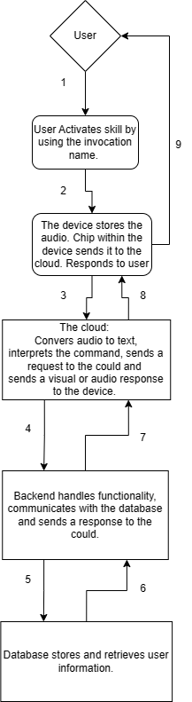

# Detailed Design

## Sequence Diagram

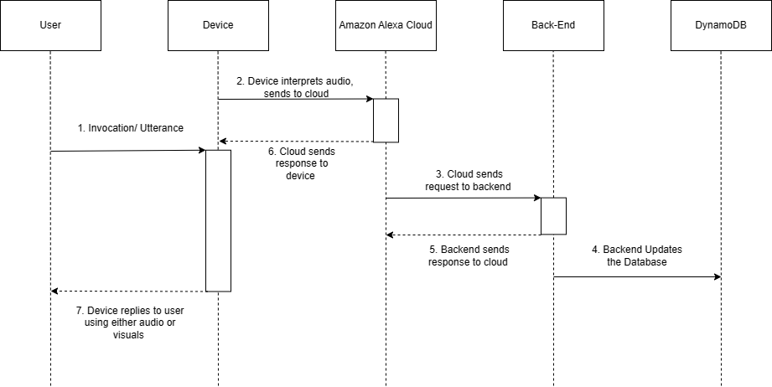

## Database Schema

The database is a flat-file database. The schema is highlighted below:

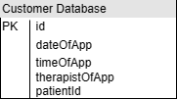

## Algorithms and Data Structures

**Automatic Speech Recognition**

Automatic Speech Recognition (ASR) allows for a computer to process human speech, or in other words an audio signal, into a written format. Algorithms associated with ASR are Hidden Markov Models (HMMs) and Deep Neural Networks (DNNs).

**Natural Language Understanding**

Natural Language Understanding applies AI techniques which allow for a computer to understand human languages and respond to human speech appropriately. The algorithm used in NLU is Natural Language Processing, which is accompanied by my machine learning as well.

**Text to Speech**

Text to speech converts text into sounds which imitate that of a human voice. The ML algorithm is responsible for processing accurate sounds through the use of a sound wave generator.

**Interaction Models Storage**

The data structure used for the interaction model is JavaScript object notation (JSON). JSON stores intents and utterances in a structured format within the models folder.

**Lambda Function**

The lambda function executes utilizing event-driven programming using AWS Lambda. The data would be stored using input and output parameters, along with communicated data from the other modules.

**Communication with DynamoDB**

CRUD (Create, Read, Update, Delete) operations are used for database interactions. The data is stored using tables in DynamoDB.